**How to run the application**

Tool used : IDE : Spring Tool Suite

Language : JAVA 8

How to run the code :

**1) Download the project1 and CSV files from Git Repository and import this project in any IDE (Spring Tool Suit, VS Code etc.).**

* Project1 and csv file path : <https://github.com/sakshisaini924/project1.git>

FYR:

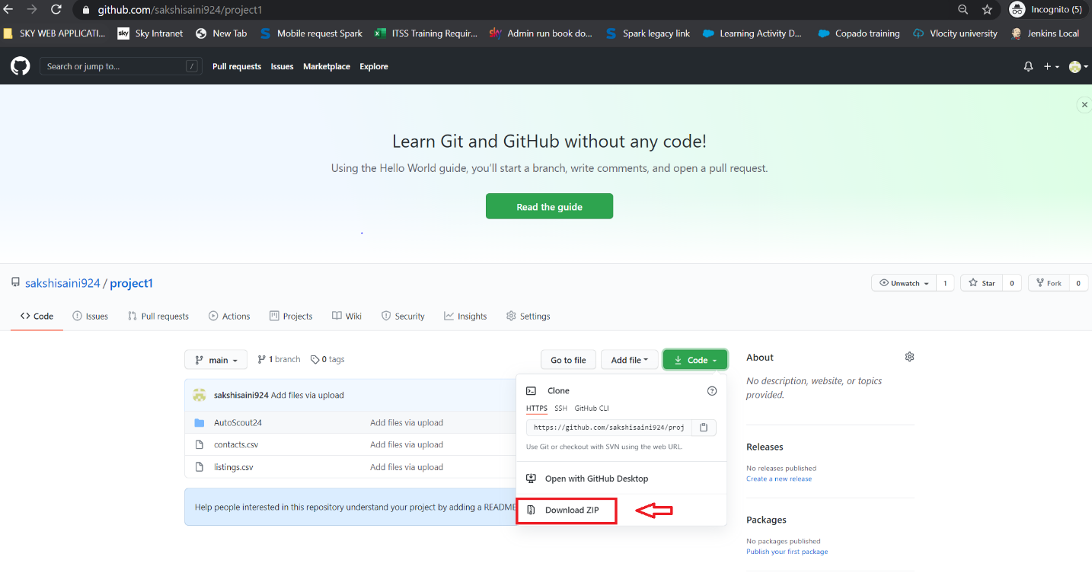

**2) Open the Application.properties from the below path** AutoScout24\AutoScout24\src\main\resources\application.properties

Provide server.port value (if needed):

* Example in my case : server.port=8787

Provide your local paths in **listingFile.path and contactsFile.path**

* Example in my case are:

listingFile.path=C:\\Users\\amsa6576\\Desktop\\AutoScout24\\listings.csv

contactsFile.path=C:\\Users\\amsa6576\\Desktop\\AutoScout24\\contacts.csv

**3) Run this project as a spring Boot application.**

**4) Once server is up and running. Hit the browser using following URL:**

<http://localhost:8787/AS24/home>

**You will see the actual application preview page like this:**

